Unit II: Managing Tables and Data in SQL (MySQL)
Detailed Notes with Related Queries and Examples
This unit teaches how to create database tables, modify them, store data, retrieve data, and manipulate data using SQL commands.

1. Creating Tables (DDL - Data Definition Language)
A table is a collection of rows and columns used to store data.
Syntax
CREATE TABLE table_name (
column1 datatype constraints,
column2 datatype constraints,
...
);

Example
Suppose we are developing a College Database.
Step 1: Create Department Table
CREATE TABLE Department (
Dept_ID INT PRIMARY KEY,
Dept_Name VARCHAR(50) NOT NULL
);
Output
Dept_ID | Dept_Name
No data yet

Step 2: Create Student Table
CREATE TABLE Student (
Student_ID INT PRIMARY KEY,
Name VARCHAR(50) NOT NULL,
Age INT,
Gender CHAR(1),
City VARCHAR(30),
Marks DECIMAL(5,2),
Dept_ID INT,
FOREIGN KEY (Dept_ID)
REFERENCES Department(Dept_ID)
);
Here
Student table depends upon Department table because of Foreign Key.
Relationship
Department
-------------
Dept_ID (PK)

|
|
↓

Student
--------------
Dept_ID (FK)

2. Constraints
Constraints maintain data accuracy.

A. PRIMARY KEY
Uniquely identifies each record.
Cannot be NULL.
Example
Student_ID INT PRIMARY KEY
Example Data
Student_ID | Name
101 | Rahul
102 | Aman
Wrong
INSERT INTO Student
VALUES (101,'Priya',20,'F','Delhi',90,1);
Error
Duplicate Entry

B. NOT NULL
Column cannot contain NULL values.
Name VARCHAR(50) NOT NULL
Wrong
INSERT INTO Student
VALUES
(103,NULL,20,'M','Delhi',89,1);
Error
Column Name cannot be NULL

C. UNIQUE
No duplicate values allowed.
Email VARCHAR(100) UNIQUE

D. CHECK
Checks condition.
Age INT CHECK(Age>=18)
Wrong
Age = 15
Rejected.

E. DEFAULT
Automatically inserts value.
City VARCHAR(30) DEFAULT 'Bhopal'
If City not entered
City = Bhopal

F. FOREIGN KEY
Maintains relationship between tables.
FOREIGN KEY(Dept_ID)
REFERENCES Department(Dept_ID)
Cannot insert department that does not exist.
Wrong
Dept_ID = 50
if Department 50 is absent.

3. ALTER TABLE
Used to modify existing table.

Add Column
ALTER TABLE Student
ADD Phone VARCHAR(15);
Before
|ID|Name|
After
|ID|Name|Phone|

Modify Column
ALTER TABLE Student
MODIFY Phone VARCHAR(20);

Rename Column
ALTER TABLE Student
RENAME COLUMN Phone TO Mobile;

Drop Column
ALTER TABLE Student
DROP COLUMN Mobile;

Add Constraint
ALTER TABLE Student
ADD CONSTRAINT chk_marks
CHECK(Marks>=0);

Drop Constraint
(MySQL syntax may vary by version.)
ALTER TABLE Student
DROP CHECK chk_marks;

Complete Database Example

Department Table
CREATE TABLE Department
(
Dept_ID INT PRIMARY KEY,
Dept_Name VARCHAR(30)
);
Insert Data
INSERT INTO Department
VALUES
(1,'Computer'),
(2,'Mechanical'),
(3,'Civil');

Student Table
CREATE TABLE Student
(
Student_ID INT PRIMARY KEY,
Name VARCHAR(50),
Age INT,
Gender CHAR(1),
City VARCHAR(30),
Marks DECIMAL(5,2),
Dept_ID INT,
FOREIGN KEY (Dept_ID)
REFERENCES Department(Dept_ID)
);

Insert Data
INSERT INTO Student
VALUES
(101,'Rahul',20,'M','Delhi',85,1),
(102,'Aman',22,'M','Mumbai',91,1),
(103,'Priya',19,'F','Delhi',78,2),
(104,'Sneha',21,'F','Indore',88,2),
(105,'Rohan',20,'M','Pune',65,3),
(106,'Anjali',22,'F','Delhi',92,1),
(107,'Riya',23,'F','Mumbai',81,3),
(108,'Vikas',20,'M','Jaipur',75,2);

4. Data Manipulation Language (DML)
DML commands manipulate the data inside tables.
Commands:
- INSERT
- UPDATE
- DELETE
- SELECT

INSERT Command
Adds records.
Syntax
INSERT INTO table_name
VALUES (...);
Example
INSERT INTO Student
VALUES
(109,'Karan',21,'M','Bhopal',82,1);

UPDATE Command
Changes existing records.
Syntax
UPDATE table_name
SET column=value
WHERE condition;
Example
Rahul's marks changed to 95.
UPDATE Student
SET Marks=95
WHERE Student_ID=101;
Before
Rahul = 85
After
Rahul = 95

Multiple columns
UPDATE Student
SET City='Jaipur',
Marks=88
WHERE Student_ID=103;

DELETE Command
Deletes rows.
DELETE FROM Student
WHERE Student_ID=108;
Only one record removed.

Delete all rows
DELETE FROM Student;
Table remains.

TRUNCATE
Deletes all rows quickly.
TRUNCATE TABLE Student;
Table becomes empty.

DROP TABLE
Deletes table completely.
DROP TABLE Student;

SELECT Statement
Used to retrieve data.
SELECT * FROM Student;
Output
|ID|Name|Marks|
All rows displayed.

Select particular columns
SELECT Name,Marks
FROM Student;

WHERE Clause
Filters records.
SELECT *
FROM Student
WHERE City='Delhi';
Output
Only Delhi students.

Another Example
SELECT Name,Marks
FROM Student
WHERE Marks>80;
Output
Rahul
Aman
Sneha
Anjali
Karan

Comparison Operators
Equal
WHERE Marks=85
Greater
WHERE Marks>80
Less
WHERE Marks<70
Not Equal
WHERE Marks<>80

DISTINCT
Removes duplicate values.
Without DISTINCT
SELECT City
FROM Student;
Output
Delhi
Delhi
Mumbai
Delhi
Pune
Mumbai
Jaipur

With DISTINCT
SELECT DISTINCT City
FROM Student;
Output
Delhi
Mumbai
Pune
Jaipur
Indore

ORDER BY
Sorts records.
Ascending
SELECT *
FROM Student
ORDER BY Marks;
Descending
SELECT *
FROM Student
ORDER BY Marks DESC;

Multiple columns
SELECT *
FROM Student
ORDER BY City,Marks DESC;
First City sorted.
Within City Marks sorted.

GROUP BY
Groups same values.
Average Marks Department-wise
SELECT Dept_ID,
AVG(Marks)
FROM Student
GROUP BY Dept_ID;
Output
|Dept_ID|AVG|
1
2
3

Count students
SELECT City,
COUNT(*)
FROM Student
GROUP BY City;

HAVING Clause
Filters groups.
Difference
WHERE
↓
Filters rows
HAVING
↓
Filters groups

Example
Department having average marks above 80
SELECT Dept_ID,
AVG(Marks)
FROM Student
GROUP BY Dept_ID
HAVING AVG(Marks)>80;

WHERE + GROUP BY + HAVING
Example
Find department average marks above 80 considering only female students.
SELECT Dept_ID,
AVG(Marks)
FROM Student
WHERE Gender='F'
GROUP BY Dept_ID
HAVING AVG(Marks)>80;
Execution Order
Student Table

↓

WHERE

↓

GROUP BY

↓

HAVING

↓

SELECT

Special Operators

1. IN Operator
Checks multiple values.
Instead of
WHERE City='Delhi'
OR City='Mumbai'
OR City='Jaipur'
Use
SELECT *
FROM Student
WHERE City IN
('Delhi','Mumbai','Jaipur');

2. BETWEEN
Checks range.
SELECT *
FROM Student
WHERE Marks
BETWEEN 70 AND 90;
Includes 70 and 90.

3. LIKE
Pattern matching.
Starts with A
SELECT *
FROM Student
WHERE Name LIKE 'A%';
Ends with a
LIKE '%a'
Contains "an"
LIKE '%an%'
Second letter is a
LIKE '_a%'

Wildcards
%

Any number of characters

_

One character

4. EXISTS
Checks whether a subquery returns any rows.
Example: Show departments that have at least one student.
SELECT Dept_Name
FROM Department d
WHERE EXISTS (
SELECT *
FROM Student s
WHERE s.Dept_ID = d.Dept_ID
);
How it works:
- For each department, SQL checks whether at least one matching student exists.
- If yes, that department is displayed.

5. ANY Operator
Compares a value with any one value returned by a subquery.
Example: Find students whose marks are greater than at least one student in Department 2.
SELECT Name, Marks
FROM Student
WHERE Marks > ANY (
SELECT Marks
FROM Student
WHERE Dept_ID = 2
);
Suppose Department 2 marks are: 78, 88, 75
The condition becomes:
Marks > ANY (78, 88, 75)
A student qualifies if their marks are greater than at least one of these values (e.g., greater than 75).

6. ALL Operator
Compares a value with every value returned by a subquery.
Example: Find students whose marks are greater than all students in Department 2.
SELECT Name, Marks
FROM Student
WHERE Marks > ALL (
SELECT Marks
FROM Student
WHERE Dept_ID = 2
);
If Department 2 marks are:
78, 88, 75
The condition becomes:
Marks > 78
AND Marks > 88
AND Marks > 75
So only students with marks greater than 88 are returned.

Complete Query Flow (How Commands Relate)
Step 1: Create Tables
│
▼
CREATE TABLE Department (...);

CREATE TABLE Student (...);

│
▼
Step 2: Insert Data
│
▼
INSERT INTO Department ...;

INSERT INTO Student ...;

│
▼
Step 3: Retrieve Data
│
▼
SELECT * FROM Student;

│
▼
Step 4: Filter Rows
│
▼
SELECT * FROM Student
WHERE Marks > 80;

│
▼
Step 5: Remove Duplicates
│
▼
SELECT DISTINCT City
FROM Student;

│
▼
Step 6: Sort Results
│
▼
SELECT * FROM Student
ORDER BY Marks DESC;

│
▼
Step 7: Group Data
│
▼
SELECT Dept_ID, AVG(Marks)
FROM Student
GROUP BY Dept_ID;

│
▼
Step 8: Filter Groups
│
▼
SELECT Dept_ID, AVG(Marks)
FROM Student
GROUP BY Dept_ID
HAVING AVG(Marks) > 80;

│
▼
Step 9: Use Special Operators
│
▼
IN, BETWEEN, LIKE, EXISTS, ANY, ALL

│
▼
Step 10: Modify Data
│
▼
UPDATE Student
SET Marks = 95
WHERE Student_ID = 101;

│
▼
Step 11: Delete Data
│
▼
DELETE FROM Student
WHERE Student_ID = 108;
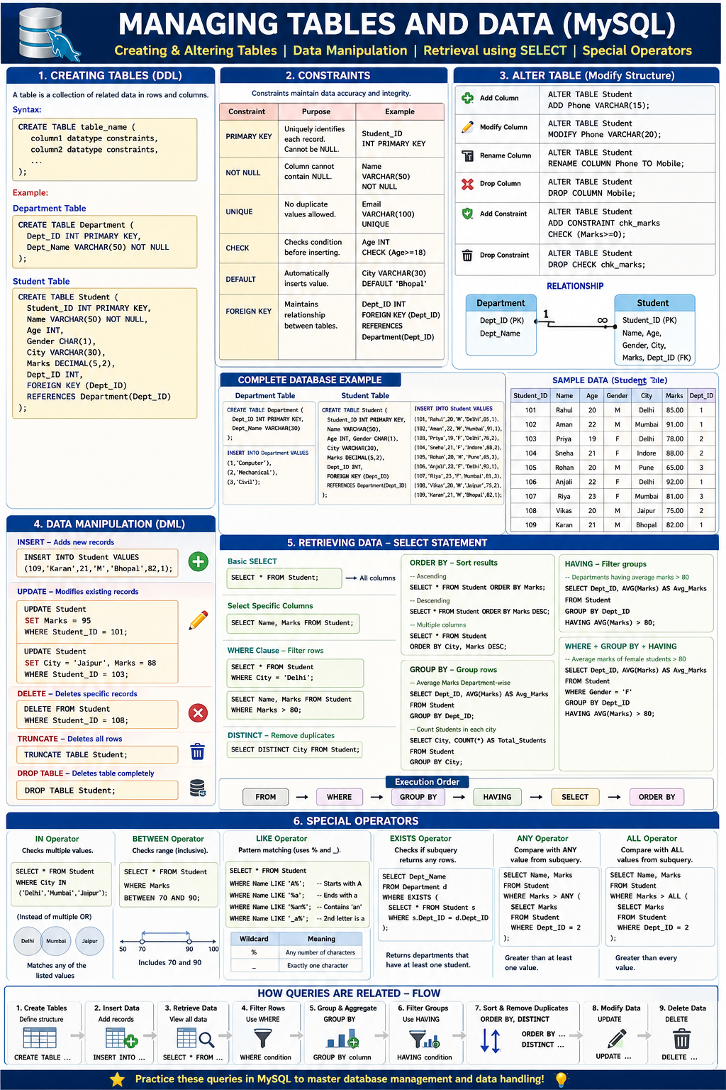

Summary Table
SQL Feature | Purpose | Example
CREATE TABLE | Create a new table | CREATE TABLE Student (...);
ALTER TABLE | Modify table structure | ALTER TABLE Student ADD Phone VARCHAR(15);
Constraints | Enforce data integrity | PRIMARY KEY, FOREIGN KEY, NOT NULL, CHECK, UNIQUE, DEFAULT
INSERT | Add new records | INSERT INTO Student VALUES (...);
UPDATE | Modify existing records | UPDATE Student SET Marks=95 WHERE Student_ID=101;
DELETE | Remove specific records | DELETE FROM Student WHERE Student_ID=108;
SELECT | Retrieve data | SELECT * FROM Student;
WHERE | Filter rows | WHERE Marks > 80
DISTINCT | Remove duplicate values | SELECT DISTINCT City FROM Student;
ORDER BY | Sort results | ORDER BY Marks DESC
GROUP BY | Group rows for aggregation | GROUP BY Dept_ID
HAVING | Filter grouped results | HAVING AVG(Marks) > 80
IN | Match multiple values | WHERE City IN ('Delhi','Mumbai')
BETWEEN | Select a range | WHERE Marks BETWEEN 70 AND 90
LIKE | Pattern matching | WHERE Name LIKE 'A%'
EXISTS | Check if a subquery returns rows | WHERE EXISTS (...)
ANY | Compare with at least one value from a subquery | Marks > ANY (...)
ALL | Compare with every value from a subquery | Marks > ALL (...)

